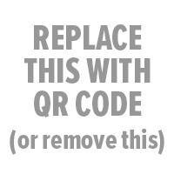

School Name Yearbook
Where: | store.shopyearbook.com/enter-path-to-store
Price: | enter a price or prices
Order By: | enter deadline date
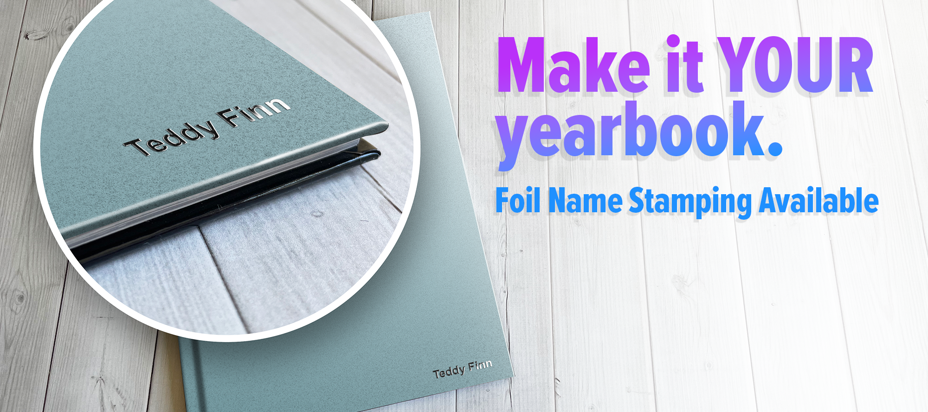

$6.99 per book

Enter name at checkout. Name will be foil-stamped on the yearbook cover.

